Final Project Report

Online Booking of Medical Appointments and Services.



Project Supervisor
Miss Anam Naveed

Submitted By:

Name: Muhammad Asif & Faizan Ali
VU ID: BC190402820 & BC190406344
Group ID: F2202C0612

Software Projects & Research Section,
Department of Computer Sciences,
Virtual University of Pakistan.

CERTIFICATE

This is to certify that Muhammad Asif & Faizan Ali has worked on and completed their Software Project at Software & Research Projects Section, Department of Computer Sciences, Virtual University of Pakistan in partial fulfillment of the requirement for the degree of BS in Computer Sciences under my guidance and supervision.

In our opinion, it is satisfactory, up to the mark, and therefore fulfills the requirements of BS in Computer Sciences.

Supervisor / Internal Examiner
Miss Anam Naveed

Supervisor,
Software Projects & Research Section,
Department of Computer Sciences
Virtual University of Pakistan.

___________________
(Signature)

External Examiner/Subject Specialist
<<External Supervisor Name>>

___________________
(Signature)

Accepted By:

_________________
(For office use only)

EXORDIUM

In the name of Allah, the Compassionate, the Merciful.

Praise be to Allah, Lord of Creation,
The Compassionate, the Merciful,
King of Judgment Day !

You are alone we worship, and to You alone we pray for help,
Guide us to the straight path

The path of those who You have favored,

Not of those who have incurred Your wrath,
Nor of those who have gone astray.

DEDICATION

This project is dedicated to the ALLAH who is most beneficent and the Merciful, to the Holy Prophet Hazrat Muhammad (PBUH), teachers and my Parents who believed in me when no one else did. Both of you give me strength and courage. The light within you inspired my awakening.

ACKNOWLEDGEMENT

Miss Anam Naveed was the best supervisor for us. In the starting of this project, in certain points, we feel like we have lost hope then we gather hope to complete the rest of project. His instructions helped us all the time with our project. Then we would like to thank our family, our parents for supporting us throughout our lives. Their blessings gave us the courage to do this project successfully.
PREFACE

Learning comes from doing. To learn something, one has to go through practical conditions. Recognizing this fact, the university made it essential for students of BSCS & BSIT to make a project. During this period, students learn about the functioning of the project and the actual environment. In addition, this training helps the student how to implement theoretical knowledge into practical life, in our day-to-day daily life.
This report puts special emphasis on operational work, tasks and projects carried out during the development period.
The main reason for choosing this project was that this project gave us a chance to build a solution for patients who couldn’t or don’t want to go physically to the doctor’s premises to book appointments and more. Therefore, through this project we will help many people and build a better and educated society.
Finally, I would like to thank everyone who guided and supported me in completing this project.
TABLE OF CONTENTS

CHAPTER NO. 1
gathering & Analyzing info 07

1.1 Introduction

1.2 Scope

1.3 definitions, acronyms and abbreviations

1.4 use cases and usage scenarios

1.4.1 Use Case Diagrams

1.4.2 Usage Scenarios

1.5 supplementary requirements

1.5.1 Usability

1.5.2 Reliability

1.5.3 Supportability

1.5.4 System Requirements

CHAPTER NO. 2
planning the project 25

2.1 Introduction

2.2 Selected Methodology

2.2.1 Chosen Methodology

2.2.2 Reasons for Chosen Methodology

2.2.3 Work Plan

CHAPTER NO. 3
designing the project 29

3.1 Introduction

3.2 Entity Relationship Diagram (ERD) :

3.3 Architectural Representation (Architecture Diagram)

3.4 Dynamic Model: Sequence Diagrams

3.5 Object Model/Logical Model: Class Diagram

3.6 DEPLOYMENT MODEL (DEPLOYMENT DIAGRAM)

3.7 Database Model (Database Diagram)

Chapter no.4
DEvelopment 49
4.1 Development plan (Architecture Diagram)

CHAPTER 1
Gathering & Analyzing Info

Introduction
Main aim of our web application named ‘online booking of medical appointments and services’ is providing an awesome platform where users can find clinics, labs and hospital so that they can book doctors and services according to their needs. In this document I cover the following topics in very detail according to my project.

Scope
Describes the requirements to build an application. It provides the surety that the software development process is according to the expectation and needs for which it is built. Online booking of Medical Appointments and Services will be built for the same purpose. This application will meet the needs of the post-COVID world. This application has extensive scope. This application will facilitate its users to get their medical checkups online. This will be an effective way to get an appointment without going out. This application will be effective in terms of cost and time. This application will be useful for patients. This application will help users to arrange their appointments according to their availability. This application has Admin and user account. Admin is an authorized person. He will be able to manage and delete data of available hospitals respective to cities. He will also manage information on labs, medical specialists, users, city, clinic, and doctors. He will be able to manage and update the doctor’s availability timing and his/her fee. Similarly, a patient is a registered user. This application will allow its user to find a doctor by using different filters such as the name of the hospital, clinic, lab, or doctor. This application will also provide the facility to its user to find a nearby doctor based on his/her current location or to find a doctor based in his city. This application is user-friendly. This application will also give information about the availability of slots of a specific doctor to get an appointment. This application will also allow its user to check different information such as the date and timing of his appointment. This application will provide a facility for its user to get an appointment for a test and check reports from the test such as test radiology department scanning X-rays. These features collectively make our application user-friendly, less time-consuming, cost-efficient, efficient, reliable, speedy, and secure. Now if I talk about its availability and compatibility it is easily accessible from anywhere around the world at any time on any kind of device which has browser support.
1.3 DEFINITIONS, ACRONYMS AND ABBREVIATIONS

- HTML (Hyper Text Markup Language)
- CSS (Cascading Style Sheet)
- Bootstrap
- Python (Programming Language with Flask Framework)
- DBMS (Database Management System)
- SQL (Structure Query Language)

1.4 USE CASE AND USAGE SCENARIOS

1.4.1 USE CASE Diagram:

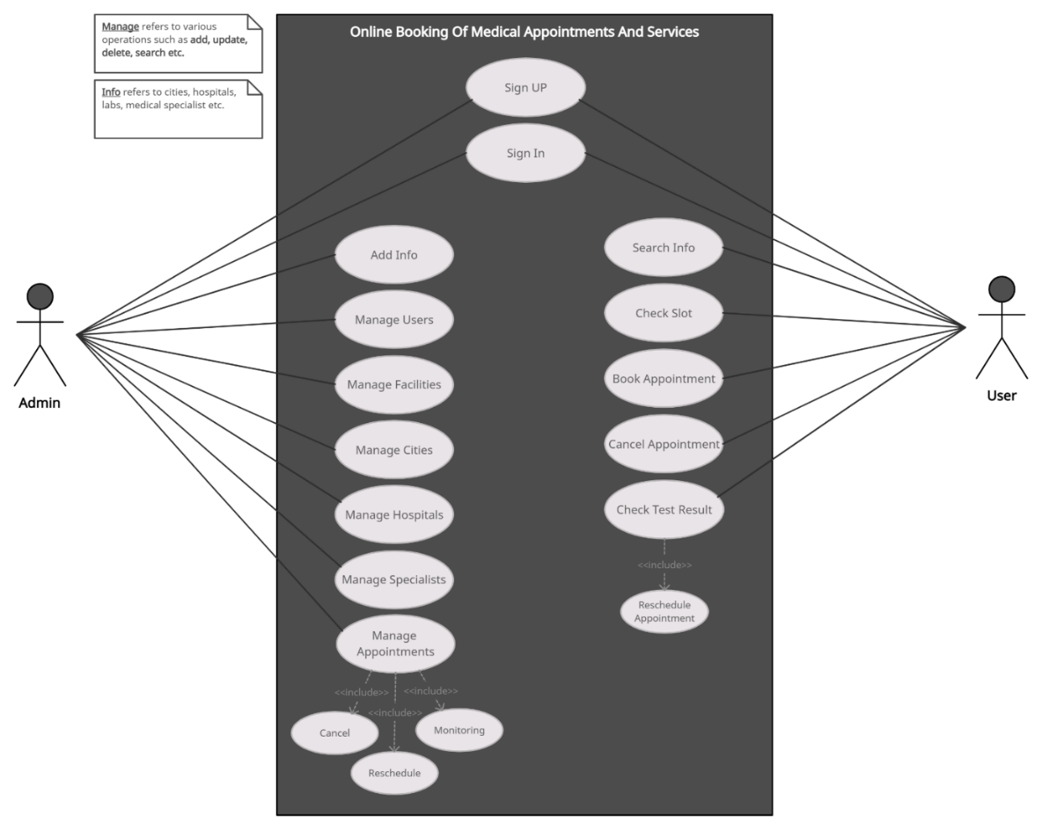

1.4.2 USAGE SCENARIO:

Use Case Title | Sign UP
Use Case Id | UC-01
Actors | Admin, User
Description | The admin and user will be able to create accounts for the system by completing the sign-up form with required and accurate information.  Sign Up form for admin is not public to the user.
Pre-condition | The system is running, and the user navigates to the sign-up form.
Actions | - Navigate to the sign-up form  - Fill in the form with accurate information.  - Submit the form.
Post-condition | Upon successful account creation, the users will be able to log in to the system using their email and password.
Exceptions | If the provided email is already existing in the system, the application will display an alert for change
FR | U-01

Use Case Title | Sign In
Use Case Id | UC-02
Actor | Admin, User
Description | Admin and Users can access the system by giving their valid sign-in credentials. They can also recover their password if they've forgotten it.
Pre-condition | Admin and users must have an active account on the system.
Actions | - Open the login page  - Enter the email and password  - Click on the login button
Post-condition | After a successful login, Admin and users will be moved on to their respective back-ends, where they can perform actions based on their roles.
Exceptions | If the login credentials are incorrect, the system will show an error message.
FR | U-02

Use Case Title | Add Info
Use Case Id | UC-03
Actor | Admin
Description | Admin can add info into the system such as adding about cities, hospitals/labs, hospital’s facilities and medical specialists etc.
Pre-condition | Admin must be logged in to the system.
Actions | - Navigates to the relevant section of adding info  - Fills out all necessary information.  - Click on the submit button.
Post-condition | Newly information is added to the system and available for usage in the system for example if admin add facility info then this info will be available for users to view and book appointments with.
Exceptions | Application prevents the duplication of information. If admin tries to submit the information with invalid format then system will display the warning message to change it.
FR | A-3, A-4, A-5

Use Case Title | Manage Users
Use Case Id | UC-04
Actor | Admin
Description | The admin can manage user accounts, including adding, updating, deleting and searching for existing user accounts into the system after logging in.
Pre-condition | Admin must be logged in to the system.
Actions | - The admin navigates to the "Manage Users" page after logging in.  - Can perform the following actions into the system under user’s section:  - Add a new user account by inputting the required information such as name, email, and contact etc.  - Update an existing user account by editing the necessary information such as name, email, and contact etc.  - Delete an existing user account by selecting it from the list of user accounts.  - Search for an existing user account by inputting the name, email etc.
Post-condition | The user accounts are managed and updated in the system.
Exceptions | If admin does not have the necessary permission for any specific operation in user section system will deny the operation and inform to the admin for example system try to prevent the deletion of that particular user with current processing of another data such as current valid bookings etc.
FR | A-2

Use Case Title | Manage Facilities
Use Case Id | UC-05
Actor | Admin
Description | The admin will be to manage hospital facilities, including adding, updating, deleting and searching for existing facilities after logging in to the system.
Pre-condition | Admin must be logged in to the system and system has related hospital or labs information stored in the system.
Actions | - Navigate to the ‘Manage Facilities’ page  - Choose the related hospital or lab for that particular facility.  - Then apply any of the following actions here.  - Add Facility  - Update Facility  - Delete Facility  - Search Facility
Post-condition | The new facility will manage and update the system.
Exceptions | The system tries to prevent the duplication or entry of the invalid facility info and return the related alert if it happens.
FR | A-1

Use Case Title | Manage Cities
Use Case Id | UC-06
Actor | Admin
Description | The admin will be to manage cities, including adding, updating, deleting and searching for existing cities after logging in to the system.
Pre-condition | Admin must be logged in to the system.
Actions | - Navigate to the ‘Manage Cities’ page  - Then apply any of the following actions here.  - Add City  - Update City  - Delete City  - Search City
Post-condition | The new city will be managed and updated in the system.
Exceptions | The system tries to prevent the duplication or entry of the invalid city info and return the related alert if it happens.
FR | A-4

Use Case Title | Manage Hospital
Use Case Id | UC-07
Actor | Admin
Description | The admin will be to manage hospitals/labs, including adding, updating, deleting and searching for existing info after logging in to the system.
Pre-condition | Admin must be logged in to the system.
Actions | - Navigate to the ‘Manage Hospitals/Labs’ page  - Then apply any of the following actions here.  - Add Hospital info such as name, location, address, image etc.  - Update info such as name, location, address, image etc.  - Delete info such as name, location, address, image etc.  - Search hospitals by giving any searching keywords such as name, location etc.
Post-condition | The new hospital/lab will be managed and updated in the system.
Exceptions | The system tries to prevent the duplication or entry of the invalid city info and return the related alert if it happens. The system also tries to deny the operation if it’s necessary such as deleting the hospitals and labs with current ongoing appointments.
FR | A-4

Use Case Title | Manage Specialists
Use Case Id | UC-08
Actor | Admin
Description | The admin will be to manage specialists/services, including adding, updating, deleting and searching for existing info after logging in to the system.
Pre-condition | Admin must be logged in to the system and there must be some pre required info will be available such as cities, hospitals/labs, departments etc.
Actions | - Navigate to the ‘Manage Specialists’ page  - Then apply any of the following actions here.  - Choose pre related data such as city, hospital, lab etc. if required.  - Add, update, delete, search and view etc.
Post-condition | The specialist info will manage and update the system.
Exceptions | System keeps track of the data on all operations and alerts on duplication.
FR | A-5

Use Case Title | Manage Appointments
Use Case Id | UC-09
Actor | Admin
Description | The admin will be able to manage appointments, including canceling, rescheduling and monitoring the existing appointments into the system after logged in.
Pre-condition | Admin must be logged in and there must be some appointments information available on the system.
Actions | - Navigate to the ‘Manage appointments’ page  - Then apply any of the following actions here.  - Cancel an existing appointment by selecting it from the appointments list  - Reschedule an existing appointment and input the new date and time.  - Monitor the appointments by viewing the list of appointments, apply various filters on it.
Post-condition | The appointments are managed and updated in the system.
Exceptions | System returns alert if admin try to add invalid date and time during rescheduling an appointment.
FR | A-5, A-7

Use Case Title | Search Info
Use Case Id | UC-10
Actor | User
Description | The user will be able to search for information about cities, hospitals, labs, services and specialists.
Pre-condition | System must contain the related information before searching it.
Actions | - Navigates to the front or open specific "Search" page in the system.  - Inputs the search criteria, such as city, hospital name, service type or specialist name.
Post-condition | The system returns a list of matching results so that users can view the desired info according to their searching keywords.
Exceptions | If searching criteria will not be matched with any record then system return no result found.
FR | U-3, U-4

Use Case Title | Check Slot
Use Case Id | UC-11
Actor | User
Description | The user will be able to check the slot before getting an appointment with the specific specialist or service.
Pre-condition | The user must be logged in to the system.
Actions | - First search and open the specific specialist or service page.  - Click on check slot for specific date and time.
Post-condition | If a slot is available then the user can apply for the appointment after logging in.
Exceptions | The user will not be able to book an appointment if the slot is already reserved.
FR | U-7

Use Case Title | Book Appointment
Use Case Id | UC-12
Actor | User
Description | The user will be able to book an appointment with the specific specialist or service after logging in.
Pre-condition | The user must be logged in and there must be a slot available for booking.
Actions | - Once a slot is available then the user will navigate to book appointment page.  - Fill in the appointment form with valid and required information.  - Click on the submit button.
Post-condition | The user’s appointment is confirmed and added to the system.
Exceptions | The system will deny the user’s appointment if it contains invalid or unrelated information.
FR | U-6

Use Case Title | Cancel Appointment
Use Case Id | UC-13
Actor | User
Description | The user will be able to cancel the booked appointment into the system.
Pre-condition | The user must have an appointment first to cancel.
Actions | - Logged into the system.  - Navigates to appointments section.  - Click on any specific appointment.  - Click on the cancel appointment button.
Post-condition | The user’s appointment will be canceled from the system.
Exceptions | The system will deny the cancel request if appointment is approved or in process.
FR | U-13

Use Case Title | Check Test Result
Use Case Id | UC-14
Actor | User
Description | The user will be able to check his/her appointment’s test result after logging in and the user will also be able to reschedule the appointment.
Pre-condition | The user must be logged in and has already taken test/appointment.
Actions | - Logged into the system.  - Navigates to appointments/tests section.  - Click on any specific appointment/test.
Post-condition | The user can check his/her test/appointment results and can reschedule the appointment as well.
Exceptions | System return alert or deny the rescheduling request if the slot’s is not available for desired date and time.
FR | U-11

1.5 SUPPLEMENTARY REQUIREMENTS

1.5.1 Usability

Usability of software is so easy that everyone can use it without any difficulty.

1.5.2 Reliability

The application is very reliable to perform and maintain member’s actions and this application also takes care of its functions in routine circumstances, as well as hostile or unexpected circumstances.

1.5.3 Supportability
The application supportability is very flexible. Members can use the application features with ease and comfortably. This system provides all features with great user friendly support. This application can be assessable through any platform.

1.5.4 System Requirements

Functional and non- Functional Requirements:

Functional Requirements:

Note: The system has two Actors:

  - Administration
  - User

Admin Requirements:
- Admin shall be able to maintain data of cities, hospitals, labs, medical specialists in the system after logged in.
- Admin shall maintain information of users.
- Admin shall add new facility offering by hospital
- Admin shall add new city, clinic, hospital, lab and doctor information.
- Admin shall add all information of a doctor/medical specialist, timings, fee and all other necessary information
- Admin shall be able to add complete information of a hospital, clinic or lab like timings, location and other facilities.
- Admin shall change the information of hospital, clinic, doctors and other information.

User Requirements:

- Users shall be able to register themselves.
- Users shall be able to login to their account.
- User shall be able to select city.
- After selecting city, User shall be able to select nearby or preferred hospital/Clinic/Lab.
- After selecting hospital, he or she has to select required facility.
- User able to book online appointments from available doctor/medical specialist on respective date and time.
- User shall be able to check free slot before booking appointment of doctor or test.
- User able to book online appointment of paramedical service, test etc.
- User able to book online appointments in radiology department for any type of scan or x-ray etc.
- User able to see all information about doctor, timings, fees, and other required information.
- Users shall be able to check the results of their test results in their respective account.
- Users shall be able to recheck the date and time of their appointments.
- Users shall be able to cancel appointments to free slot.

NON-FUNCTIONAL REQUIREMENTS:

- Performance: Performance is a quality attribute of our application. Through this user’s interactions are fast and reliable and users interact with the system without any delay. Our application handles a high volume of traffic and requests easily.

- Security: Our application has secure login mechanisms, encryption for sensitive data, and protection against common web attacks for example SQL injection and cross-site scripting, etc.

- Reliability: Our application behaves consistently in a user-acceptable manner when operating within the environment for which the system was intended.

- Scalability: Our application has great compatibility and responsiveness so it can be accessed on any kind of device (mobile, tab, desktop) which has support for the browser.

- Usability: In our application, all kinds of users will be satisfied with the usability of the system because our application is very easy to use and navigates into a consistent and friendly user interface.

- Availability: Our application is going to be web-based, which means it can be available 24/7 hours.

CHAPTER 2
Planning the Project

2.1 INTRODUCTION

This planning phase will take you through how to create a project plan. If we have a strong project plan then it will help ensure your project performance throughout development. The first step is to choose a methodology that suits your project.

2.2 Selected Methodology:

2.2.1 Chosen Methodology:

VU Process Model:

After analysis of the different methodologies, we found only one methodology which fits our project is VU Model. According to the “Flight Information display and Ticket Reservation System” I have selected Modified VU Process Model because this model fulfills our software development requirements. VU process Model is proposed software engineering process by Virtual University of Pakistan which is the combination of Waterfall Model and Spiral Model in software development. Following Diagram shows the stages of VU process Model.
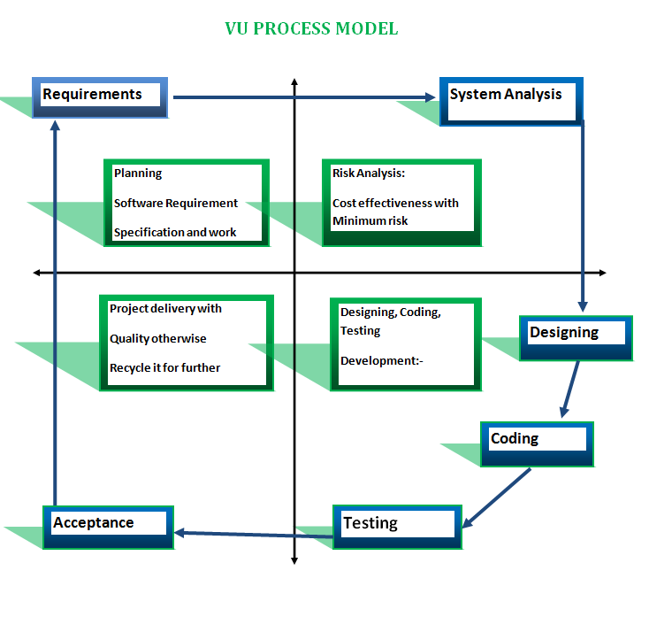

The above model is VU Process Model. It has Four phases, and these include Requirement, analysis and design, Implementation and Results. The mixture of both Methodologies Waterfall Model and Spiral Model is called hybrid approach of the system. It maximizes the quality of the system and minimizes the disadvantages and risk. VU process Model uses four phases of Spiral Model and divides Waterfall Model phase in it. That’s why I will follow the VU process model for my application project. Furthermore, its progress is obvious and considerable.VU process Model has several advantages and fulfills our Requirements.VU process Model is relatively simple but effective. It gives better project vision and control over milestones. Project requirements are an essential feature of VU Process model and development member has accurate project requirements. It helps to implement effective progress tracking due to distinct development stages. Modified VU Process is actually a customized Software Development Life Cycle strategy mainly designed according to requirements of the project.

Reasons for choosing the Methodology:

- It is a consecutive model within reverse redundancy.
- It is a more compact and propelled show than waterfall demonstrates in light of the fact that we can do a reversal at any phase of improvement which is not permitted in waterfall display.
- Every activity is performed in an arrangement in VU Process Model.
- On the off chance that we need to do correction at any stage in the event that we need advancement and redundancy at whatever point vital then we can pick VU process model.

Work Plan (Use MS Project to create Schedule/Work Plan):

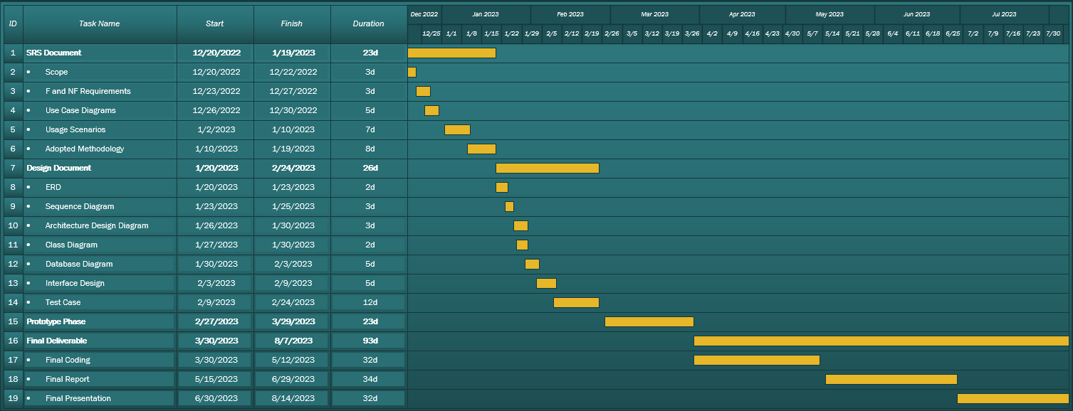

CHAPTER 3
Designing the Project

3.1 INTRODUCTION

Design Document is very important and essential for the project development process which helps us understand how our online booking of medical appointments and services application will build in the right way. This document is a problem-solving plan for our project which covers all aspects and provides a great understanding of Online Booking of Medical Appointments and Services. It also helps us to understand how its components related to each other. Once we have a solid understanding of the design document and know the purpose of this document, let’s have a look at some key functionality of our application. This application will help users to arrange their appointments according to their availability. This application has Admin and user account. Admin is an authorized person. He will be able to manage and delete data of available hospitals respective to cities. He will also manage information of labs, medical specialists, users, city, clinic, and of doctors. He will be able to manage and update the doctor’s availability timing and his/her fee. Similarly, a patient is a registered user. This application will allow its user to find a doctor by using different filters such as the name of hospital, clinic, lab, or doctor. This application will also provide the facility to its user to find a nearby doctor based on his/her current location or to find a doctor based in his city. This application is user-friendly. This application will also give information about availability of slots of a specific doctor to get an appointment. Now by keeping functionality in mind we build multi diagrams such as ERD, Sequence, Class and database diagrams, etc. which help us to understand our system and lead towards successful project implementation easily.

3.2 Entity Relationship Diagram (ERD) :

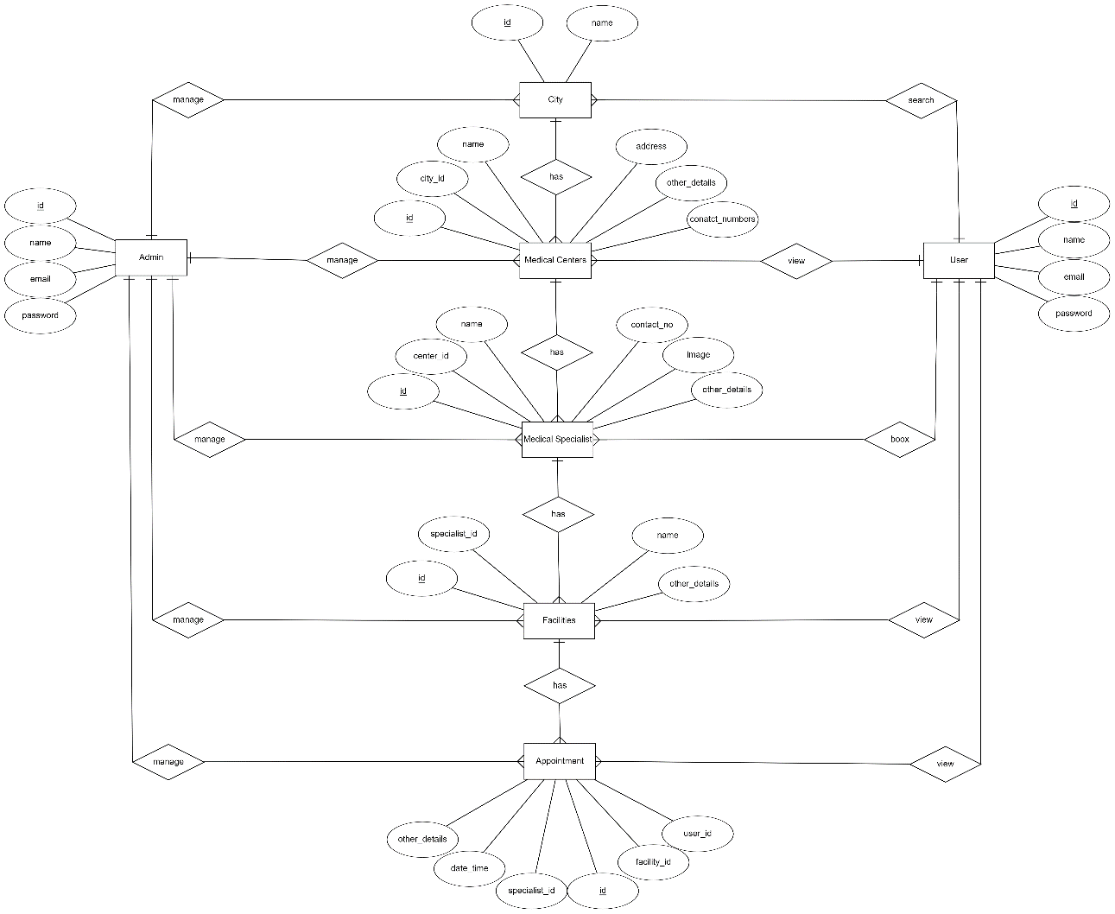

3.3 ARCHITECTURAL REPRESENTATION
(ARCHETECTURAL DIAGRAM)

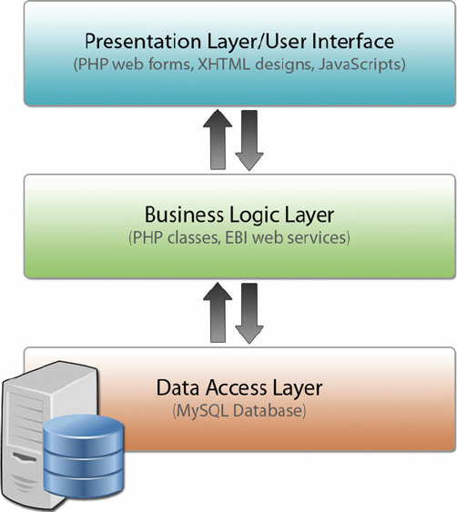

3.4 DYNAMIC MODEL: SEQUENCE DIAGRAM

Create Account:
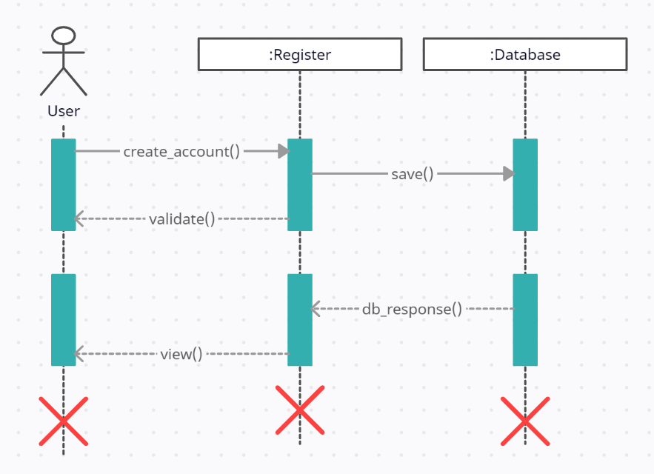

Login:
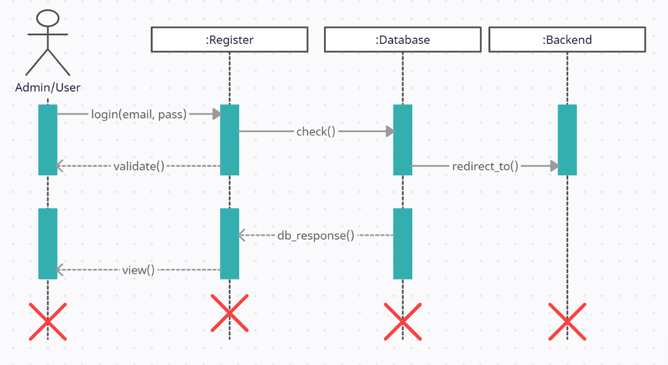

Add Info:
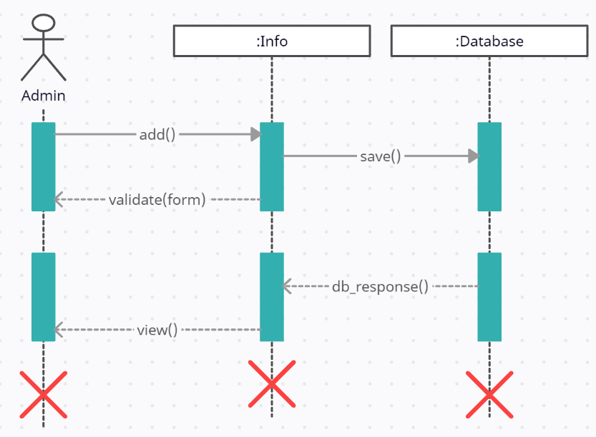

Manage Users:
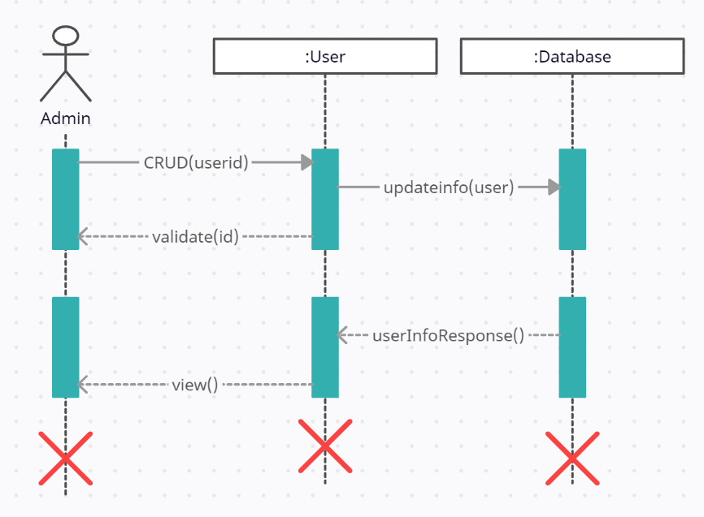

Manage Facilities:
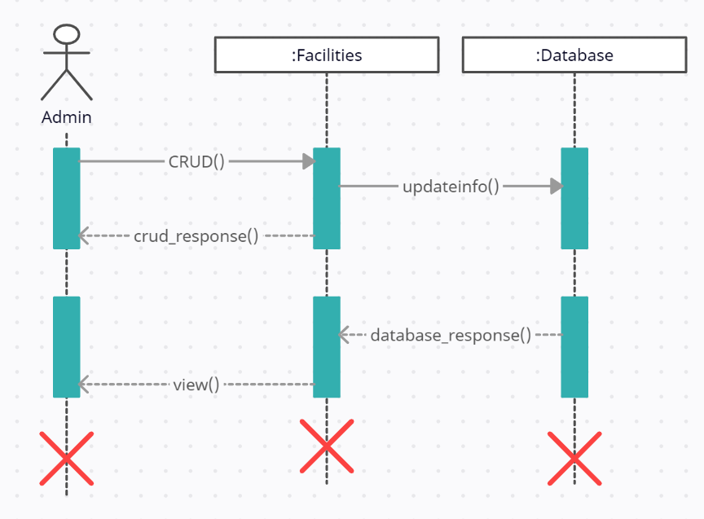

Add Cities:
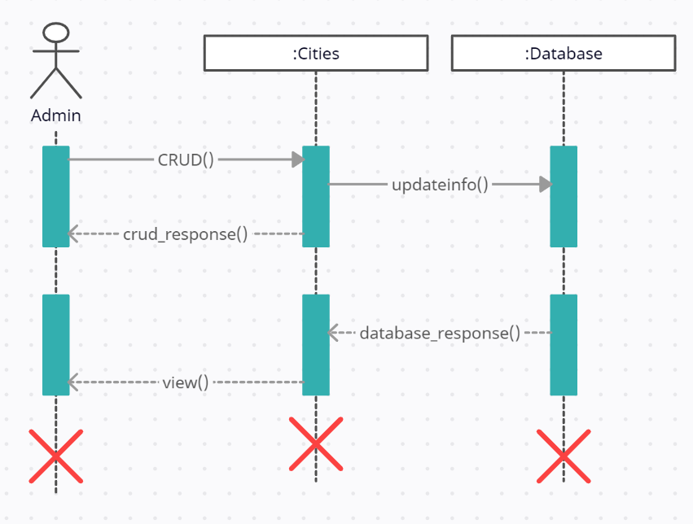

Manage Hospitals:
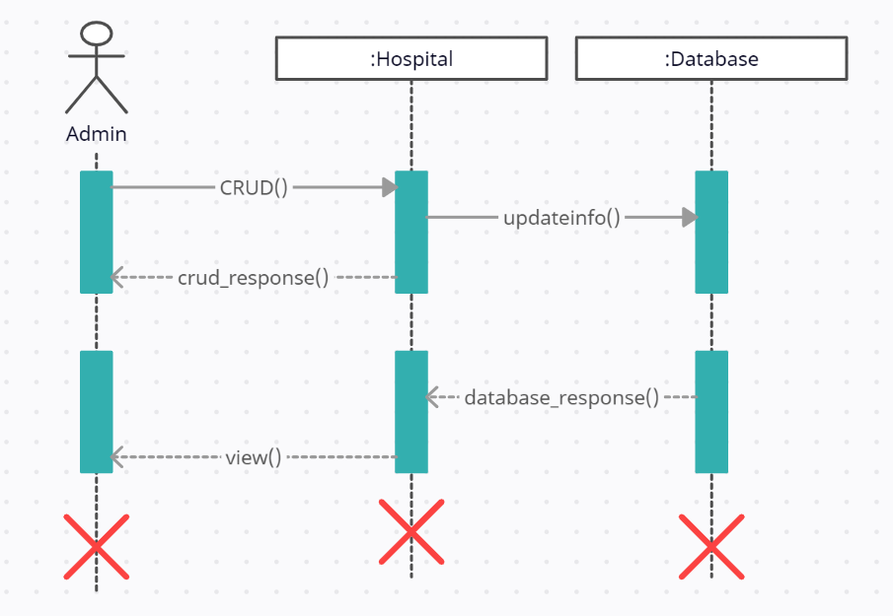

Manage Specialists:
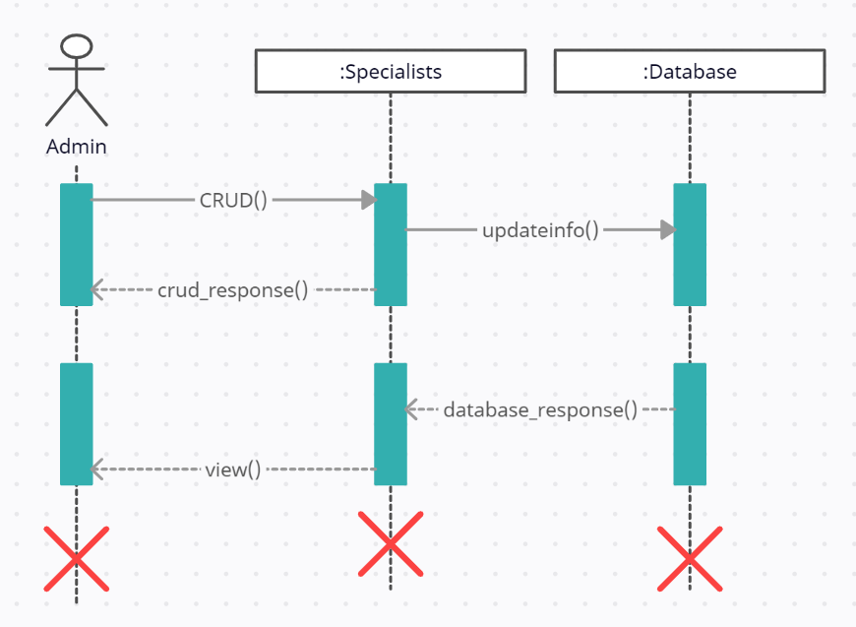

Manage Appointments:
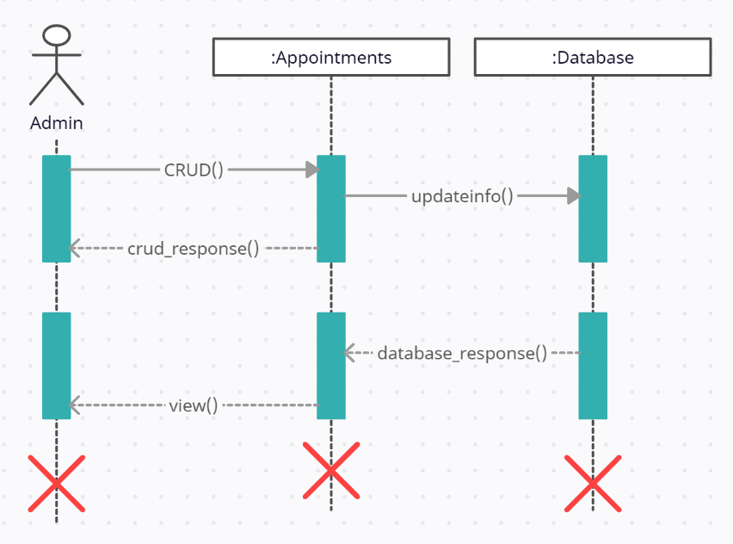

Search Info:
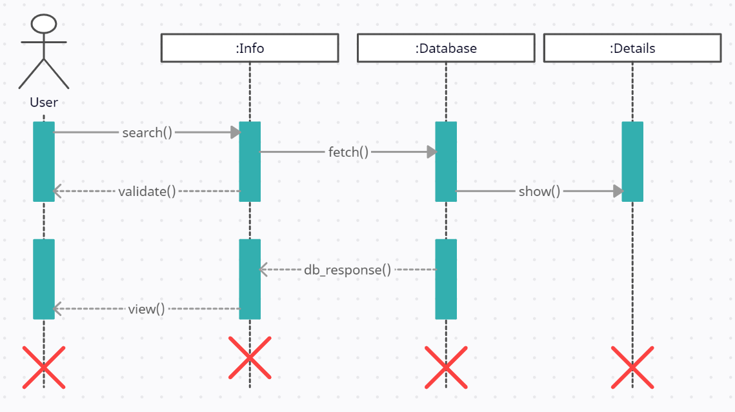

Check Slots:
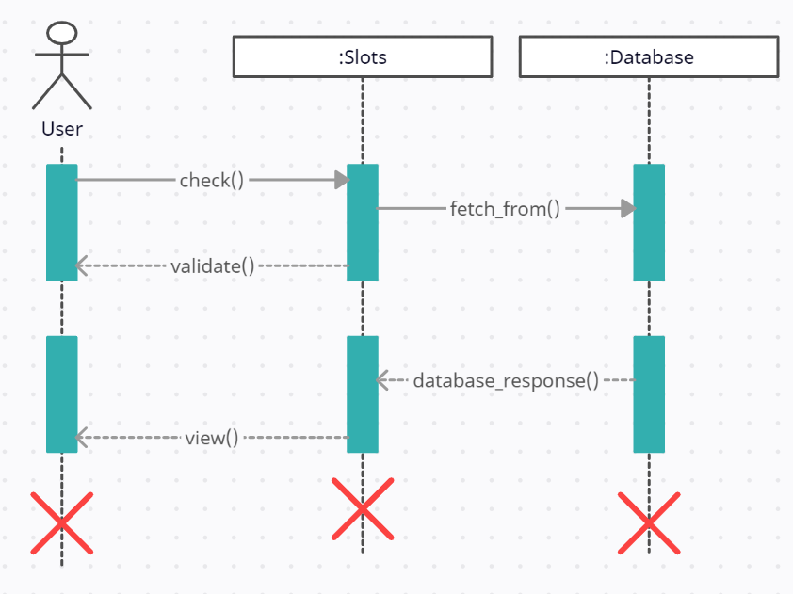

Book Appointments:
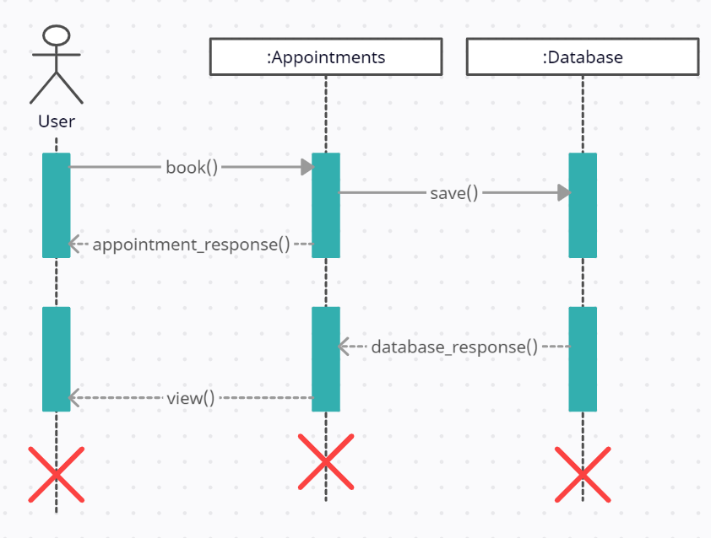

Cancel Appointment:
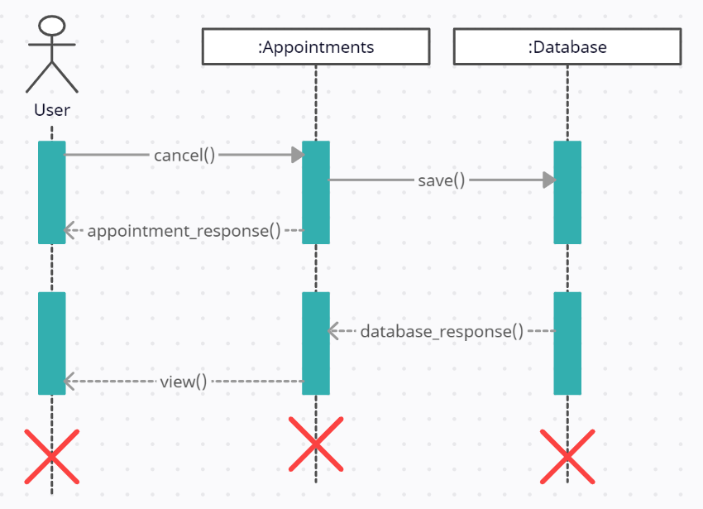

Check Test Results:
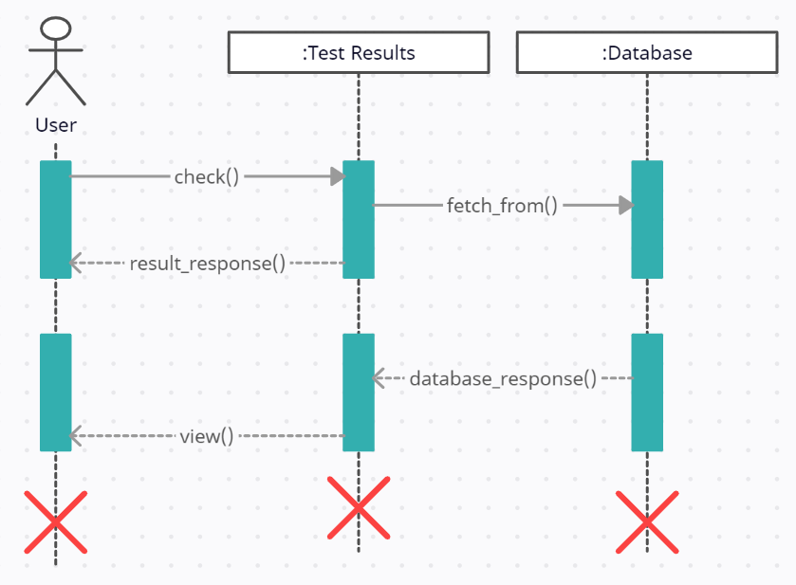

3.5 OBJECT MODEL/ LOGICAL MODEL: CLASS DIAGRAM
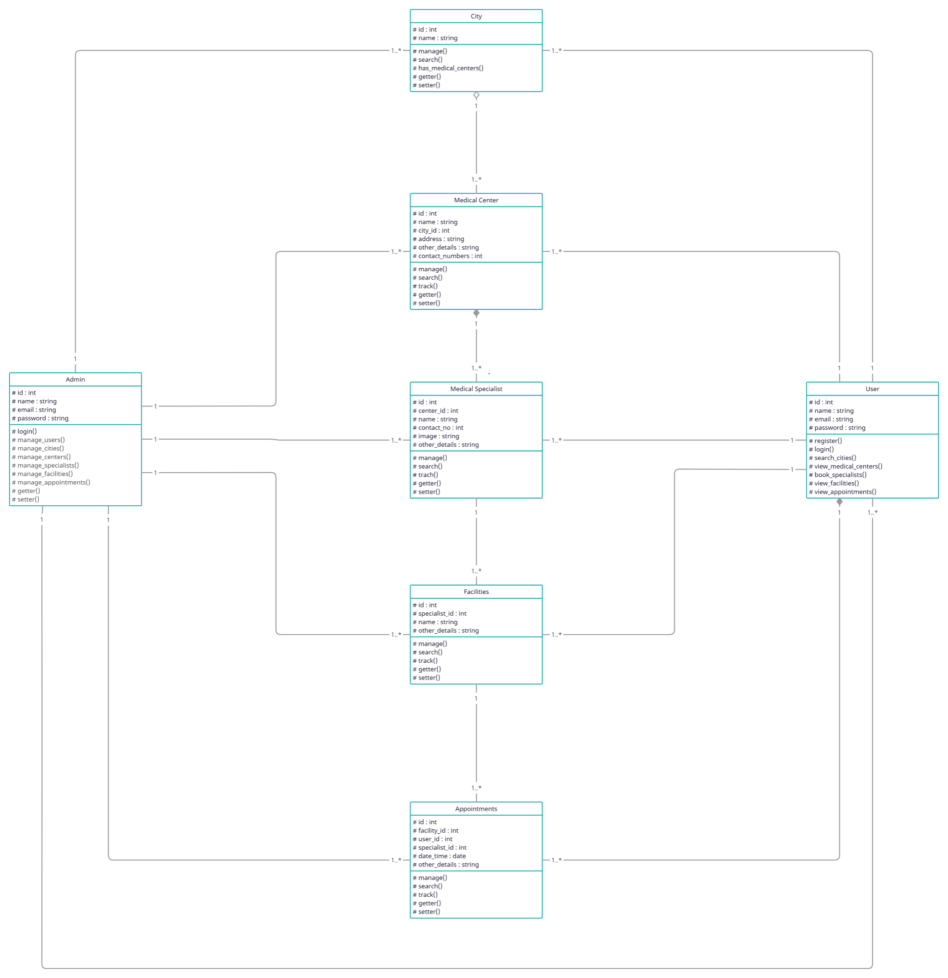

3.6 Deployment Model (Deployment Diagram)

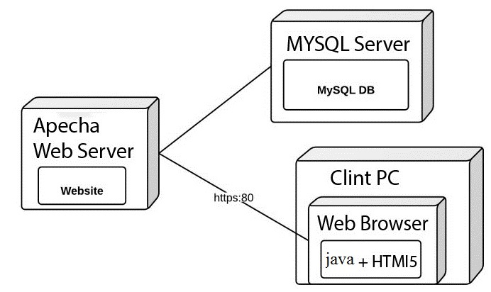

3.7 DATABASE MODEL (DATABASE DIAGRAM)

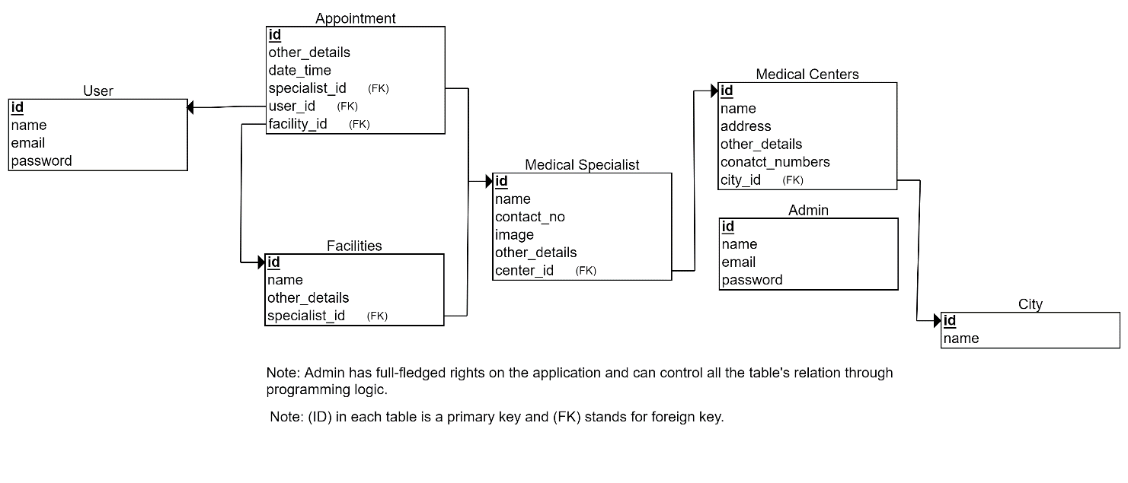

CHAPTER 4
Development

Coding folder is placed with the final report and final ppt as a separate folder.

REFERENCES

Handout CS403 – DBMS
Handout CS504 – Software Engineering - 1
Handout CS605 – Software Engineering - 2
-----------------------------------------------------------------

